**X. Electronic Payment** **2 hours**

Electronic Cash, Credit Card Processing, Electronic Check Processing, Gift and Prepaid Certificates, Payer Authentication, Smart Authorization

**Electronic Cash**

* Money that is exchanged electronically over computer or telecommunications networks.
* Any of various systems of payment for purchases made on the Internet.

As more consumers and businesses migrate to online shopping and digital transactions that even include multiple currencies, payment methods have had to evolve to facilitate these new preferences. One of the financial solutions that have emerged is known as ecash. This article explores the various types of products that are referred to as eCash and describes the pros and cons of using each type.

**What is eCash?**

In providing a simple definition of eCash, also known as electronic cash, it is a digital money product that provides a way to pay for products and services without resorting to paper or coin currency. Two models emerged for e-cash transactions:

* The online form of eCash, which was introduced by the now defunct DigiCash, worked for all types of Internet transactions.
* The offline form of e-cash involved a digitally encoded card that replaced paper money. Mondex developed and tested this model with different banks, but the company has now transitioned into the development and management of smart cards also used for financial transactions.

**A Historical Context for eCash Development**

eCash is an evolutionary product that has its roots in other payment concepts. Others have noted that checks were essentially the same idea because they have involved stating that an amount will be taken from one account and then placed in another.

During this process, no currency is actually transferred. Instead, banks take care of changing the amounts in both accounts to reflect the transaction. eCash removes the bank from the payment equation but essentially does the exact same thing as a check.

**How eCash Works**

An eCash user will download the electronic money from their bank account and store this on their hard drive. When they are ready to use the electronic cash to pay an Internet merchant or shareware provider, the same software is then used to take the amount from their eCash “wallet” and add it to the merchant’s “wallet.”

The e-cash goes through an e-cash bank so that the transaction can be verified. The merchant or shareware provider can then choose to pay their expenses with this eCashor upload it to a traditional bank account for use later. Transactions do not incur a fee except for a small amount charged by the e-cash company. This makes it ideal for smaller online transactions than any other payment method.

**The Benefits of Using eCash**

eCash solves some issues that developed from trying to conduct transactions across the Internet. As more discussions have emerged about paying for content on the Internet, being charged to visit a website, or agreeing to pay a download fee, there was no viable solution in place to cover such small transaction amounts. Using a credit card for a ten or twenty-five cent transaction was just not fiscally smart for businesses given the processing fees attached to these transactions.

Another issue that emerged was that shareware providers rarely got paid for what they offered because there was no viable way to do so unless they wanted to receive an offline monetary payment. eCash became a solution that was not only address this new type of transaction, but it was also cheap, secure, and private.

eCash also responds to the globalization of the economy. Now that companies and freelancers are doing business with others all over the world, eCash has provided a way to receive or send any type of currency desired.

Last, eCash also has linked offline and online payments together through the introduction of smart card technology. Money can be loaded onto these cards and then moved to other smart cards or electronic “wallets.” While previously smart card technology was just used for phone calls, the world is now using smart card technology for all types of transactions.

**Changing Financial Transactions Forever**

It’s clear the world of financial transactions has changed forever since the advent of eCash. Checks and paper money could be eventually replaced with completely digital payments. This will also alter how banks and other financial intermediaries are involved, delegating them to a much smaller role as just a storehouse for money, a processor and verifier, and a lender. The personal relationship with a bank will also fall by the wayside as more people turn to their computers, tablets, and smartphones for all their transaction needs.

**Credit Card Processing**

**What is credit card processing?**

Businesses rely on credit card processors to handle the details of accepting credit and debit cards, whether in person, over the phone, or online. Dependent on a third party to perform such a crucial service can make anyone anxious. This quick primer seeks to relieve that anxiety by outlining the basics of credit card processing.

**How credit card processing works?**

First, a customer presents their credit card info for payment. This presentation can take many forms:

* in-store via a swiped magnetic stripe card;
* in-store via a dipped EMV chip card;
* in-store via a tapped NFC-enabled card;
* from your website or app via a payment gateway;
* via a mobile point of sale;
* via a virtual terminal

The payment information is then sent to the processor, who communicates with the customer’s bank via the appropriate card networks (such as Visa or Mastercard).

The customer’s bank approves or denies the transaction. Approval is dependent on detailed verification including card number validity, sufficient available funds, and other factors.

That approval is sent back through to your payment processor and then finally back to your terminal or credit card reader.

You’ll then send batches of approved transactions for settlement; typically at the end of each business day. At that point, your customers’ accounts will be charged and the transaction amounts will be deposited into your merchant bank account (less processing, interchange and other fees).

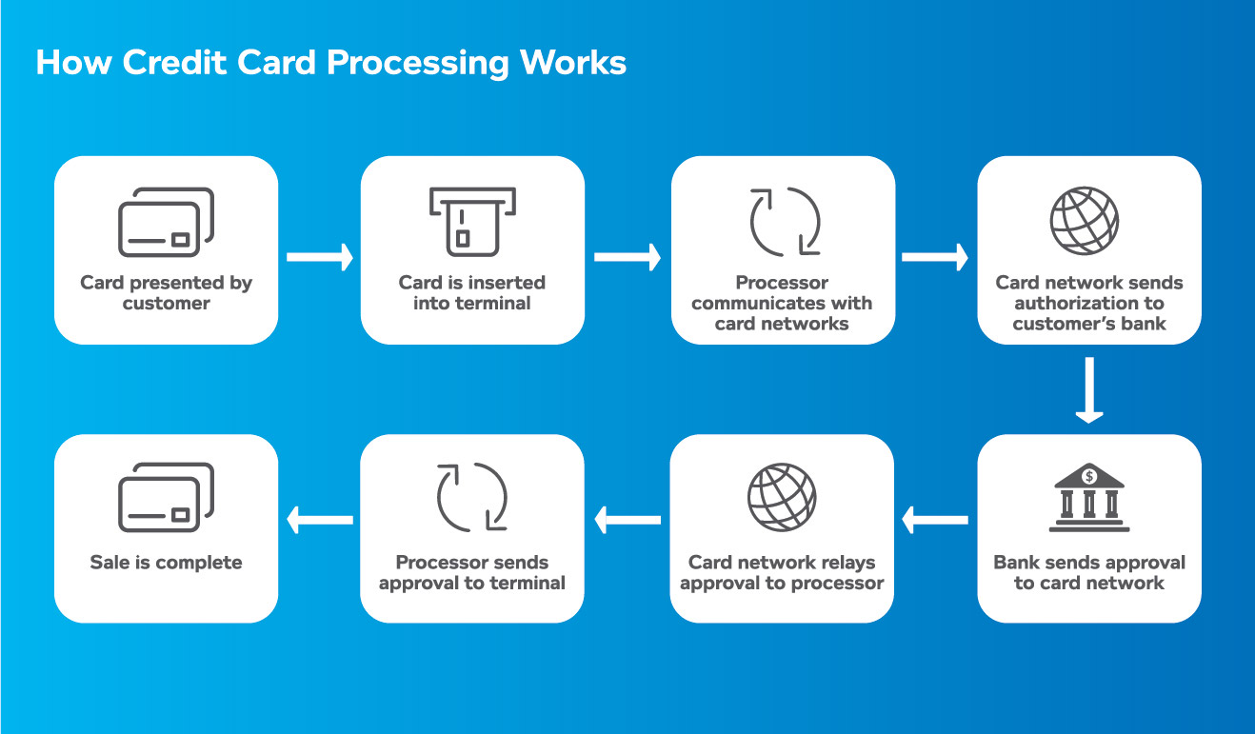

**Credit Card Processing: Quality Matters**

Credit card processing services vary in quality. When evaluating potential companies, ask tough questions about these four critical areas where credit card processing quality matters most to your business:

* Transaction speed and reliability
* Strong uptime record
* Fair and transparent rate structure
* Access to helpful customer support

**Transaction speed and reliability**

Your customers love to pay with debit and credit cards, but they take the speed of such payments for granted. Even short delays can cause big annoyances. You’ll want to choose a processor capable of processing a high volume of transactions safely, accurately, and quickly.

What counts as “fast?” In the early 1990s, merchants connected to payments network via dial-up which took up to a minute per transaction. A decade later when processing via broadband became the new standard, a tech savvy processor could boast about delivering two-second transactions. This is the speed that modern customers have come to expect.

The introduction of EMV chip cards has slowed down transactions down, since the card must be dipped and left in the terminal until the approval clears. Customers seem willing to exchange better fraud and identity protection for slightly longer transaction times, and the payments industry is working to reduce processing time further.

The right credit card processor can help you keep things moving by accepting mobile transactions on your phone or tablet. NFC, or Near Field Communication, allows you to accept payment merely from contact, where the customer taps their phone to the terminal to complete a payment.

Even more important is the ability to take process credit cards online. eCommerce markets continues to explode in size, with even the smallest businesses embracing online sales. Of course, you’ll need a credit card processor that will allow your business to seamlessly accept card payments in-store, online, or wherever you do business.

**Strong uptime record**

Simply put, outages are bad for business. A credit card processing outage means your business as good as shut down. It’s not just the downtime itself that hurts, as customers turned away during an outage may view your business as untrustworthy and/or inconvenient. That’s not the brand association small business owners are looking for.

Credit card processing outages are rare, but all complicated interdependent systems are vulnerable to downtime. Outages can occur in multiple places—such as the card brands and bank networks—that processors don’t have control over. Reliable processors like Vantiv, now Worldpay, have solutions to help merchants stay operational during a network outage, as well as redundant servers to reduce their own risk of going down.

When you’re doing your research, ask about a credit card processor’s uptime history, the steps they’ve taken to minimize downtime, and backup plans in the event of downtime.

**Fair and transparent rate structure**

The rates and fees you’ll pay depend on many factors, starting with the interchange category applicable to your business. Though payment processors charge their own rates and fees on top of interchange, the cost of interchange is set by the card brands and is the same for all processors. Interchange pricing varies based on the risk factors of different types of businesses.

This is particularly relevant if most of your transactions qualify as “small tickets” or “convenience purchases” according to the card brands and their interchange models. Quick service restaurants, convenience stores, and movie theaters are examples of businesses that may benefit from being placed on an interchange level that will charge a high-volume, low-ticket business more fairly.

Make sure you’re quoted and charged appropriately by your processor if your business qualifies for a lower rate structure.

**Customer support can make or break your day**

Dealing with technology and managing complex systems is part of modern life. As a business owner, you know that troubleshooting and maintenance is part of every critical service. However, the way that service providers respond to those difficulties can make a big difference to your sanity and your bottom line.

When things go wrong, you need to be able to count on support from real people who know how payments work, know what your terminal or POS system’s common failures are, and how to resolve them. You need to be able to speak to someone right away when you call—whether it’s in the middle of the night, or on a busy holiday.

Not all credit card processors offer 24/7 live customer support. If you can’t be left in the lurch, make sure that any processing company you consider offers the level of service your business demands.

Reputable payment processors keep track of their call waiting times and resolution scores, so be sure to ask about them.

Now that you have a better idea of what credit card processing is all about, dig deeper into the articles that follow to learn more. If you have question, we're here to help. Let us know a little bit about your business and one of our payments experts will get in touch to help get you started.

**Electronic Check Processing**

**How Electronic Check Payment Processing Works?**

If you have been running a business for a while, the chances are high that a customer has requested to make payment using an eCheck. However confusing merchants find this method, they often choose to let their payment processors handle the technicalities. And when disputes later arise, the trader is left with little to do, other than concede to the processor’s demands.

As a business owner, therefore, it is important to have at least a little grasp of what goes on when a client pays through an eCheck. But first, let’s answer the obvious question: what is an eCheck?

An electronic check is a form of payment where a customer’s funds are transferred into a merchant’s account over the ACH (Automated Clearing House) network. To process such payments, a trader requires an eCheck processing, through which payments made by eChecks can be withdrawn directly from the client’s bank account.

**How to get an eCheck merchant account**

If your business already accepts credit cards, your current merchant account provider might be willing to incorporate ACH processing to your already existing system. Companies such as eMerchantBroker offer both cards and eCheck payment services to online businesses.

Once you’ve identified a processing account that agrees with your needs, it is time to fill out the application. The information required will include your estimated processing volumes, as well as the years your business has been in operation. The application process is usually fast and easy, and approval typically takes a few days.

**How eCheck processing works**

In some ways, electronic check processing is similar to paper check handling, albeit faster and more efficient.

Processing an eCheck generally takes place in the following steps.

**The purchase is authorized**

To approve the purchase, a customer can either fill out an online form or talk to the merchant directly through a recorded phone call. Only after authorization can the trader pass the check information to the payment processor.

**Payment is finalized**

The payment processor oversees the direct withdrawal of the funds specified by the check from the customer’s bank account, and prints out a receipt.

**Funds are deposited into the merchant’s bank account**

It takes two to three days after initiating the transaction for the check to clear and the money to be deposited into the merchant’s account.

**Recurring payments with eChecks**

Credit cards might be the most common way to make payment online, but when it comes to recurring transactions, eChecks make the most sense. Consequently, ACH billing is gradually gaining traction among property managers as a reliable way to collect monthly rent.

Businesses that charge customers fixed fees at every end of a specified duration should, therefore, adopt eChecks as a primary payment method.

**How Electronic Check Payment Processing Works**

There was a time — not long ago, really — when a person wrote a personal check, the recipient delivered it to their bank for deposit and it was processed manually. The process could take days to complete, which meant the depositor had to wait for the funds to clear.

Today, new technology has eliminated much of the delay by turning a paper check into an electronic transfer (debit), also known as an electronic check or e-check. If you’re a merchant or service provider, this means funds are electronically transferred from a customer or client’s bank account directly into your bank account through the Federal Reserve Bank’s Automated Clearing House (ACH) system.

Electronic check payment processing is check cashing simplified, and a hassle-free and inexpensive way to get paid faster. It’s just one of many merchant services that TSYS® provides to help you meet all of your payment processing needs.

**The e-Check Process**

The process begins when your customer writes a paper check at the point of sale. As a merchant or service provider, you run the check through a reader or imager that captures the required information, including the check number, account number and the bank’s routing number and merchant-related information to complete the one-time electronic payment.

A receipt is generated and printed for the check writer to sign, the check is voided and returned to them. The transaction will then appear on the customer’s bank statement as a debit, not a check.

You then upload the captured check information for processing, and the proceeds are deposited into your merchant account within a day or two. The process is similar for a check that is mailed, except you retain the check after it is voided.

**Benefits of Electronic Check Processing**

Electronic check processing offers numerous benefits. It eliminates the need to take checks to the bank, there are no deposit slips to complete, it reduces the chance of checks being lost or stolen and you get paid faster.

If you’re working from more than one location, checks can be converted at each location and funds deposited into one main account. Guarantee programs expedite the collection process by discovering NSF (insufficient funds) checks and other returned items.

**Gift and Prepaid Certificates**

A gift card also known as gift certificate in North America, or gift voucher or gift token in the UK is a prepaid stored-value money card, usually issued by a retailer or bank, to be used as an alternative to cash for purchases within a particular store or related businesses. Gift cards are also given out by employers or organizations as rewards or gifts. They may also be distributed by retailers and marketers as part of a promotion strategy, to entice the recipient to come in or return to the store, and at times such cards are called cash cards. Gift cards are generally redeemable only for purchases at the relevant retail premises and cannot be cashed out, and in some situations may be subject to an expiry date or fees.

American Express, MasterCard, and Visa offer generic gift cards which need not be redeemed at particular stores, and which are widely used for cashback marketing strategies. A feature of these cards is that they are generally anonymous and are disposed of when the stored value on a card is exhausted.

From the purchaser's point of view, a gift card is a gift, given in place of an object which the recipient may not need, when the giving of cash as a present may be regarded as socially inappropriate. In the United States, gift cards are highly popular, ranking in 2006 as the second-most given gift by consumers, the most-wanted gift by women, and the third-most wanted by males.[citation needed] Gift cards have become increasingly popular as they relieve the donor of selecting a specific gift.In 2012, nearly 50% of all US consumers claimed to have purchased a gift card as a present during the holiday season.[3] In Canada, $1.8 billion was spent on gift cards, and in the UK it is estimated to have reached £3 billion in 2009,[needs update] whereas in the United States about US$80 billion was paid for gift cards in 2006.The recipient of a gift card can use it at their discretion within the restrictions set by the issue, for example as to validity period and businesses that accept a particular card.

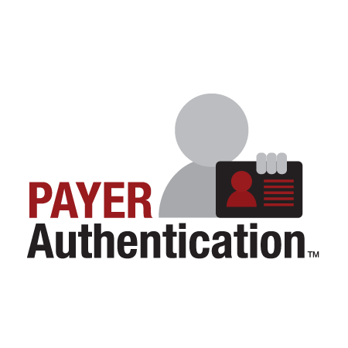**Payer Authentication**

Payer Authentication – also known as Verified by Visa (VbV) and MasterCard SecureCode, are security protocols made by Visa and MasterCard that allow consumers to shop online more securely. The incentive merchants have to use this feature is that Visa and MasterCard provide lower interchange rates and chargebacks protection to merchants.

In short, Payer Authentication is a validation procedure that the online shopper is the card holder. Merchants participating in this program are helping fight identity theft and consumers become more inclined to continue shopping at these secure online sites.

**Key Features**

* **Reduced Chargebacks** – Merchants using Payer Authentication are getting more protection against chargebacks.
* **Interchange Discounts** – Some merchants may experience lower interchange rates.
* **Lower Fraud Screening and Manual Review Costs** – merchants spend less time and money reviewing and detecting suspicious transactions.
* **Expand Internationally** – Merchants can increase business in foreign markets with less risk.

Payer Authentication, also known as Verified by Visa (VbV) and Master Card Secure Code™, are security protocols developed by Visa and MasterCard that allow consumers to shop online more securely. Visa and MasterCard also give back to e-Commerce businesses that enable these programs by providing chargeback protection and lower interchange rates. Simply put, Payer Authentication is validation that the online shopper is the cardholder. Merchants participating in the programs are helping to fight identity theft and consumers are thanking them by repeat shopping at these secure websites. Verified by Visa and MasterCard SecureCode are the #1 sought after fraud tool for the second year in a row according to industry Annual Online Fraud Reports.

**How does Verified by Visa and MasterCard SecureCode work?**

VbV and SecureCode enable cardholders to create aPIN (or “secure code”) and assign it to their credit card. During checkout, the Customer is prompted to enter their PIN and the cardholder’s identity can then be confirmed by their Card Issuing bank. The Card Issuer provides additional data elements to confirm the cardholder’s identity. The data elements are amended to the authorization and settlement messages, thus providing the proper benefits of VbV/MCSC.

**What are the benefits of Verified by Visa and MasterCard SecureCode?**

With the programs, Visa and MasterCard aim to increase consumer confidence in online shopping and reduce fraud. To encourage 3-D Secure adoption, Visa and MasterCard offer significant merchant benefits including:

• Fraudulent chargeback protection (per the rules of Visa and MasterCard)

• Interchange discounts averaging 20 basis points

• Dramatic reduction in the fraud screening costs and manual review

• Higher AOV (Average Order Value); secure, confident Customers spend more

• Free and automatic platform upgrades

• Expand internationally, risk-free

• Consumer brand loyalty and security

**What is the path of a Payer Authentication transaction?**

Transactions from your system are routed to both the card associations, as well as the banking authentication networks via an Internet connection through the Payment Gateway. This authentication information can be accessed in real-time through the gateway's comprehensive reporting system, allowing you to easily identify authenticated transactions and recognize fraudulent ones. Enabling authentication does not interrupt the current authorization process.

1. During checkout, information about the cardholder is directed to the appropriate card association to check their program enrollment status.

2. If the cardholder is enrolled, an authentication form will be displayed by the cardholder’s bank. This form will collect the password and the bank will validate it is correct.

3. Results of authentication are returned in less than one second. The results, new data elements, are proof that the merchant authenticated or attempted to authenticate the cardholder.

4. The transaction is then sent for authorization through typical processes and channels. The new data elements (ECI and CAVV) are also submitted during the authorization request, thus providing the appropriate benefits associated with VbV and MCSC.

**Smart Authorization**